

Environmental Policy Statement

Willshee’s recognise the importance of environmental protection and is committed to operating its business responsibly and in compliance with all environmental regulations, legislation and approved codes of practise specifically relating to the management of waste and recycled materials and incorporating our overall business activities.

It is our objective to operate with, and to maintain good relations with all regulatory bodies, and to carry out all measures reasonably practicable to facilitate the ability to continually improve environmental performance, we will:

- Assess and regularly re-assess the environmental effects of our equipment, plant, and operations.
- Adhere to all relevant regulations concerning waste and environmental well-being.
- Ensure that all supplier and sub-contracted operations are in-line with this policy, and that they are aware of their respective responsibilities in the environment.
- Train all employees in environmental issues and raise awareness and actively promote the establishment of a clean and healthy working environment.
- Minimise the production of waste and material wastage.
- Minimise energy wastage by promoting the effective use of energy, water, and other resources.
- Reduce and/or limit the production of pollutants to water, land, and air.
- Dispose of waste complying with all applicable legislation when recycling and/or the re-use of materials is not an available option.
- Control noise emissions from operations
- Minimise risk to public and employees from Willshee’s operations and activities.
- Regularly monitor and assess our performance and revise our quality management system as required, to ensure continuous improvement and to comply with the needs and demands of our customers, applicable legislation, and our accreditations.
- To regularly monitor and assess our performance and revise our environmental management system as required, to ensure continuous improvement and to comply with the needs and demands of our customers, applicable legislation, and our accreditations.

This policy is communicated to all employees, suppliers and sub-contractors and is made available to the public.

All personnel understand their obligations under this policy statement and abide with the principals and contents of our Environmental Management System.

The M.D. has overall responsibility for this policy, and it will be reviewed annually.

Signed:

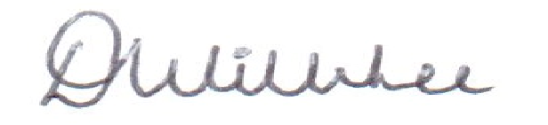
Dean Willshee
Managing Director
EPM01, V12, Issue date: 2nd January 2026

Willshee’s Waste & Recycling Ltd, 22 Granary Wharf, Wetmore Road, Burton-on-Trent DE14 1DU. Tel: 01283 702 340

