DEPARTMENT | Operations | 
PROCESS | Policy
TITLE | 068 – Carbon Reduction Policy

Carbon Reduction Policy

Willshee’s Waste & Recycling Ltd is based in Burton-on-Trent and Swadlincote and was established in 1984. We have a substantial portfolio of Public Sector and Commercial and Industrial clients. Sustainability is a key priority for our business, and we are committed to reducing our environmental impact.
Increased carbon dioxide emissions have been shown to cause climate change and global warming. Carbon reducing measures form an integral part of our overall company strategy, which will help to improve operational performance and a reduction in potentially harmful emissions to land, water, and air.
This policy supports our Environment Policy and describes our commitment to reducing our carbon footprint.

We endeavor to:

- Comply with all applicable legislation, regulations, codes of practice and guidelines.
- Evaluate alternative resources to ascertain their potential benefit to a carbon reduction.
- Ensure correct use and maintenance of equipment to maximise efficiency.
- Wherever possible resource our materials from suppliers who operate in an environmentally friendly manner, supply environmentally friendly products and who are geographically local to us to reduce transportation and associated carbon emissions.
- Follow and promote the waste hierarchy to extract the maximum practical benefits from products and to generate the minimum amount of waste for disposal at landfill sites.
- Encourage and develop our employees, interested parties, external providers, customers, contractors, and visitors to conduct their activities in a manner to reduce their carbon footprint.

The Directors and management team are responsible and committed to driving, innovating, and delivering a reduction in our carbon footprint across our business.

Signed:
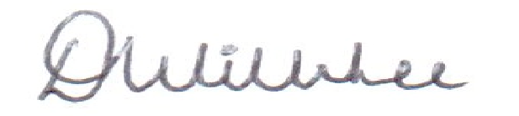
Dean Willshee
Managing Director

Jan 2023, 068, V3, Reviewed 02/01/26, K. Roberts. Page 1 of 1

