DEPARTMENT | Operations | 
PROCESS | Policy
TITLE | 005 - Anti-Slavery Policy

Anti-Slavery and Human Trafficking Statement and Policy
Slavery and human trafficking are a crime and a violation of fundamental human rights. It takes various forms, such as slavery, servitude, forced and compulsory labour and human trafficking, all of which have in common the deprivation of a person's liberty by another in order to exploit them for personal or commercial gain.
Willshee’s Waste & Recycling Ltd is committed to driving out acts of slavery and human trafficking within its business and from within its supply chains. We have a zero-tolerance approach to slavery and human trafficking. We are committed to acting ethically and with integrity in all our business dealings and relationships and to implementing and enforcing effective systems and controls to ensure that it does not take place anywhere in our business or in any of our supply chains.
This policy considers, and supports the policies, procedures and requirements documented in our Environmental, Quality and Health & Safety Management Systems, compliant with the requirements of ISO 14001:2015, ISO 9001:2015 and ISO 45001:2018.
We endeavour to:
- Comply with all applicable legislation, regulations, codes of practice and guidelines.
- Ensure there is transparency in our own business and in our approach to tackling slavery and human trafficking throughout our supply chains, consistent with our disclosure obligations under the Modern Slavery Act 2015.
- Engage with our supply chains to convey to them our Anti-Slavery and Human Trafficking Policy and to act at all times in a way which is consistent with its aim.
- Utilise supply chains that comply with this policy and provide us with confirmation that they have not and will not commit any offence involving slavery and human trafficking.
- Implement and enforce effective systems and controls to ensure slavery and human trafficking is not taking place anywhere within our business.
- Obligate employees under their contract of employment to adhere to this policy.
- Develop training for our staff to ensure a high level of understanding of the risks of slavery and human trafficking in our supply chains and our business.
- Encourage openness and support anyone who raises genuine concerns in good faith under this policy.
- Undertake disciplinary action, which could result in dismissal for misconduct or gross misconduct for any employee who breaches this policy.
- Terminate our relationship with other individuals and organisations working on our behalf if they breach this policy.
- Continually assess, monitor, review and improve our control systems and procedures to ensure they are effective in driving out acts of slavery and human trafficking.
The Directors and management team are responsible and committed to drive, innovate, and deliver anti-slavery and human trafficking practices across our business.

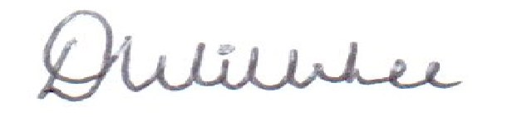
Signed:

Dean Willshee
Managing Director
Jan 2023, 005, V8, Reviewed 02/01/26, K. Roberts. Page 1 of 1

